­­

Please Remember:

Monday: Swimming Kits



Wednesday: PE Kits



Thursday: Spellings and homework

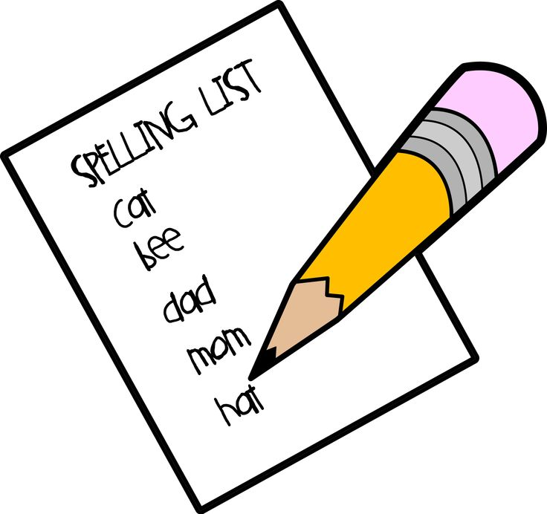

Everyday: Bookbag and reading record

**Topic Work**

Our Topic this term will be The Great British Bread Off. The children will be designing, tasting and making bread. We will be going on a school trip to the Cooperative to learn about and make bread. If any parents and carers would be willing to help out feel let us know.

**Staff that work with us:**

**Phoenix Class**

Miss Barker- Class Teacher

Tuesday Afternoon- Miss French– Teacher

**Sphinx Class**

Miss Easton – Class Teacher

Monday Afternoon- Miss French– Teacher

This year there will be 3 TAs helping us learn Miss Gittins, Miss Ellis and Mrs Thermou.

**English**

Our core story this term will be The Minpins by Roald Dahl. We will be focusing on describing the setting in the story.

**Maths**

Our main focus in Maths will be place value of numbers to 1000. Children will need to read and spell numbers up to 1000. We will be using the column method to add and subtract 2 and 3 digit numbers.

**School opens at 8.40am** This is a chance for your child to read on the morning. Please feel free to join your child and listen to them read until 8.55am every morning.



Year 3 News

**Wykebeck Primary School**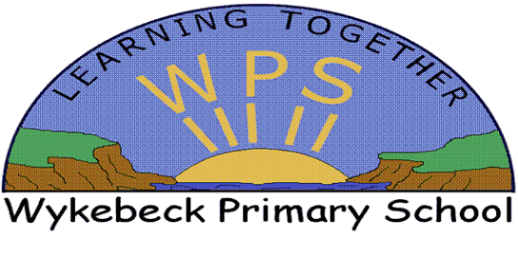

**Homework** Your child will have homework every Friday and this will need to be returned on the following Thursday. Please ensure the homework is completed in Learning Logs.

**September 2017**

Dear Parents/Carers,

Welcome to Year 3! Hope you enjoyed your summer break. Here is some important information about this term and what your child will be learning about in the curriculum. If you need anything, please do not hesitate to contact us.

Miss Easton and Miss Barker

 wjm